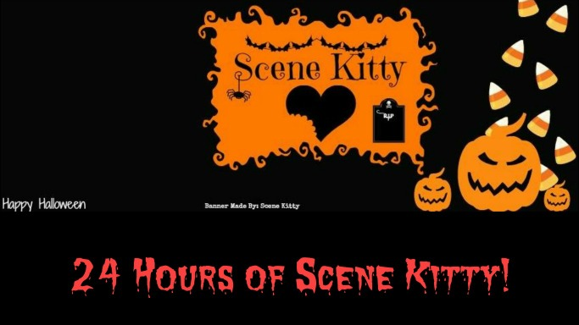

October 30-31, 2015

I survived.

_________________ has made it through the 2015 Stream 'N' Scream. 24 hours of Scene Kitty! Congratulations brave Kitten!

Keep meowing your way into tomorrow, together and forever!